
Tertiary Infotech Academy Pte Ltd
UEN: 201200696W
LEARNER GUIDE
For
Agentic AI Applications with Claude Code
TGS Ref No: TGS-2025052468
Conducted by
Tertiary Infotech Academy Pte Ltd
UEN: 201200696W
Version 1.9

DOCUMENT VERSION CONTROL RECORD
Version Number | Effective Date of Release | Summary of Included Changes | Author
1.0 | 27 Jun 2026 | First version — Topics 1–3 (Claude Code fundamentals, tools & commands, skills/agents/hooks), step-by-step activities and command reference | Dr. Alfred Ang
1.1 | 27 Jun 2026 | Added Claude product family, AI-engineering evolution timeline, harness engineering, pricing, the .claude directory, hooks automation, sub-agents rationale, and the assessment flow & LMS details | Tertiary Infotech Academy Pte Ltd
1.2 | 27 Jun 2026 | Added the 7-step build workflow (Activity 1a/1b), use cases & agentic-loop example, CLI-install-via-VS-Code tip, Hooks activity (real CC hooks + form pre/post), and the capstone build-prompt template | Tertiary Infotech Academy Pte Ltd
1.3 | 2 Sep 2026 | Added Claude for Chrome and Claude for Science to the Claude product family; added the Plan step to both agentic-loop lists; added the SKILL.md vs CLAUDE.md distinction to Topic 3.1. | Tertiary Infotech Academy Pte Ltd
1.4 | 2 Sep 2026 | Reworked Activity 6 from form pre/post hooks to a floating WhatsApp widget with a 10-second auto-open hook, suggested queries and voice activation. | Tertiary Infotech Academy Pte Ltd
1.5 | 4 Sep 2026 | Added a user-level vs project-level comparison (commands, MCP tools, skills, CLAUDE.md, hooks) to section 2.0 The .claude Directory, aligned to the new slide 42 of the 68-slide deck (v14.0) | Tertiary Infotech Academy Pte Ltd
1.6 | 9 Sep 2026 | Added a “Key Concepts Summary — What Triggers What” section covering CLAUDE.md, skills, tools, slash commands, hooks and sub agents and their triggers; expanded 3.1 with a SKILL.md vs CLAUDE.md comparison table. | Tertiary Infotech Academy Pte Ltd
1.7 | 9 Sep 2026 | Added the Lab Materials section describing the four restructured lab folders. Fixed table column widths so all comparison tables render both columns. | Tertiary Infotech Academy Pte Ltd
1.8 | 9 Sep 2026 | Removed the final project and presentation requirement; retained the connected activities, deployment checks and assessment flow. | Tertiary Infotech Academy Pte Ltd
1.9 | 29 Oct 2026 | Aligned with slide deck v21: added annotated screenshots with step-by-step explanations for the Claude Desktop Code tab, installing the VS Code extension and docking it in the secondary side bar (Activity 1 set-up), allowing bypass mode in VS Code and Desktop (1.9), and creating a GitHub repository and pushing with Claude in Activity 1, Step 5. Added a page footer (Page X of Y + copyright). | Tertiary Infotech Academy Pte Ltd

TABLE OF CONTENTS
Topic 1 — Claude Code Fundamentals 6
Topic 2 — Tools and Commands 19
Topic 3 — Skills, Agents & Hooks 23

How to Use This Guide
This learner guide follows the three topics of the course and contains step-by-step instructions for every hands-on activity. Keep it open beside Claude Code as you work. During the open-book assessment you may refer to this guide, the slides and any approved materials.
By the end of the course you will have built, deployed, tested, secured and optimised a real software-development company website — entirely with Claude Code.
What you need before you start:
- A computer with internet access (macOS, Linux or Windows)
- Claude Code installed and signed in
- A GitHub account
- Node.js installed (for npx commands)

Topic 1 — Claude Code Fundamentals

1.1 Overview of Claude Code
Claude Code is an agentic coding tool that runs in your terminal. Instead of autocompleting code line by line, you give it a goal in plain English and it plans the work, edits files, runs commands, uses tools, and verifies the result.
Key ideas:
- Terminal-native — runs where you already work.
- Agentic — plans and executes multi-step tasks.
- Tool-using — reads/writes files, runs bash, calls MCP servers.
- Extensible — custom commands, skills, sub agents and hooks.

The Claude product family
Anthropic offers several Claude products — all powered by the same Claude models, differing in where they run and who they’re for:
- Claude.ai — the chat assistant on web, desktop and mobile for everyday tasks.
- Claude Code — agentic coding tool in your terminal, IDE and desktop.
- Claude Cowork — desktop agent for non-developers to automate files and tasks.
- Claude Design — generates polished UI and frontend designs.
- Claude for Microsoft — Claude inside Microsoft 365 and Outlook.
- Claude for Chrome — browser agent that navigates and acts on the web for you.
- Claude for Science — speeds up research workflows for scientists and labs.

The evolution of AI engineering (2023 → 2026)
As models grow more capable, the work shifts from wording a single prompt to engineering the whole system around the model:
- 2023 — Prompt Engineering: craft the wording of a single prompt to get good output.
- 2024 — Context Engineering: curate what the model sees — files, memory and tools.
- 2025 — Harness Engineering: build the system around the model — loop, tools, verification.
- 2026 — Harness Systems: agents run long tasks autonomously (Claude Code, Cowork, Codex).

What Claude Code can do
Claude Code handles real engineering tasks end to end — you describe the outcome and it does the work: build features and whole apps, debug & fix errors, refactor & improve existing code, and automate git, tests, deployment and CI/CD. Common use cases: marketing sites and landing pages, internal web tools, full-stack apps, mobile apps, scripts and automations, and data tasks.

The agentic loop in action
Example — you ask: “Build a responsive software-dev website with an enquiry form, then test it.”
- Gather context — reads the folder and CLAUDE.md to understand the existing site and conventions.
- Plan — drafts the approach (hero, testimonials and enquiry form sections) for you to approve.
- Take action — writes index.html, styles.css and script.js with form validation.
- Verify work — opens the page via the Playwright MCP and submits the form to test it.
- Repeat — spots a validation bug, fixes script.js, re-tests, then reports done.

What is harness engineering?
A harness is the system built around the model — the agentic loop, tool access, context and memory management, and verification and guardrails — that turns a capable model into an agent which can complete long-running tasks. Harness engineering is designing that scaffolding (and stripping it back as models improve). Examples of harness systems include Claude Code, Claude Cowork, OpenAI Codex, Gemini CLI, OpenClaw and Hermes Agent. The guiding principle: build the simplest harness that works, and re-examine it with every new, more capable model.

1.2 The Agentic Loop
Every task Claude Code performs runs the same repeating cycle:
- Gather context — read files, run searches, use tools to understand the task.
- Plan — decide the approach and, for bigger tasks, confirm the plan before making changes.
- Take action — edit code, run commands, call tools to make progress.
- Verify work — run tests, lint, view output to check the result is correct.
- Repeat — feed results back as new context and loop until the goal is met.
Why it matters:
- Give direction, not micro-steps — state the goal and constraints clearly.
- Verification is everything — give Claude a way to check its own work (tests, linters, screenshots).
- Steer mid-loop — review the plan, interrupt and course-correct.
- Context is the fuel — what Claude can see determines what it can do.

1.3 Context Engineering
Context engineering is curating exactly what Claude sees so it has the right information and nothing that wastes its limited context window.
Tool | Purpose
CLAUDE.md | Project memory loaded every session. Generate with /init.
@ mentions | Pull specific files or folders into context on demand.
/compact | Summarise the conversation to reclaim context space.
/clear | Wipe the slate for a fresh, unrelated task.
Best practices: keep CLAUDE.md short and high-signal; pull in only what’s needed with @file; /compact at natural breakpoints; /clear between unrelated tasks.

1.4 Setting Up Claude Code
Claude Code runs in three interfaces — the same agentic loop everywhere:
- Terminal (CLI): install once, then run claude in any project folder.
  - macOS/Linux: curl -fsSL https://claude.ai/install.sh | bash
  - Windows (PowerShell): irm https://claude.ai/install.ps1 | iex
- IDE (VS Code): install the Claude Code extension (also works in Cursor and JetBrains). Gives inline diffs, @-mentions with line ranges, and plan review. The extension bundles its own CLI for the chat panel; install the standalone CLI too if you want to run claude in the integrated terminal. Tip: you don’t have to install the CLI by hand — in VS Code just ask Claude Code: “install claude cli in the terminal for me”.
- Desktop app: a full GUI for parallel sessions, scheduled tasks (Routines), and connectors.
Sign in once with any paid Claude plan (Pro, Max, Team, Enterprise) or a Console account.
Pricing (as of June 2026 — verify at claude.com/pricing): Claude Code is included in subscription plans from Pro ($17/mo annual, $20 monthly) upward — Max (from $100/mo, 5× or 20× usage), Team ($20/seat standard, $100/seat premium), and Enterprise ($20/seat + usage at API rates). It’s also available pay-as-you-go via the API, billed per million tokens (input / output): Opus 4.8 $5 / $25, Sonnet 4.6 $3 / $15, Haiku 4.5 $1 / $5.

1.5 How Claude Code Works — Built-in Tools
Tools are what make Claude Code agentic. Each tool result feeds back into the loop. The built-in tools fall into five categories:
Category | What Claude can do
File operations | Read, edit, create, rename and reorganise files
Search | Find files by pattern, grep content, explore the codebase
Execution | Run shell commands, tests, builds and git
Web | Search the web, fetch docs, look up errors
Code intelligence | See type errors/warnings, jump to definitions (with plugins)
Claude also has tools for spawning subagents and asking you questions. Extend the base set with skills, MCP, hooks and subagents.

1.6 The Context Window
Claude’s context window holds the system prompt, CLAUDE.md, auto memory, your conversation, file reads, command output, loaded skills, and MCP tool names. As you work, it fills up.
- Run /context to see what’s using space; /mcp for per-server cost.
- Near the limit, Claude auto-compacts: it clears old tool outputs first, then summarises the conversation. Detail from early in the chat can be lost — put persistent rules in CLAUDE.md.
- MCP tool schemas are deferred (loaded on demand); subagents run in their own context, so they don’t bloat yours.

1.7 Memory Files
Each session starts fresh. Two mechanisms carry knowledge across sessions:
- CLAUDE.md — you write it: instructions, conventions, build/test commands. Generate a starter with /init. Keep it under ~200 lines. Scopes: project (./CLAUDE.md or ./.claude/CLAUDE.md), user (~/.claude/CLAUDE.md), or managed (organisation). Loaded in full every session.
- Auto memory — Claude writes it: learnings and patterns it discovers. Stored as MEMORY.md (plus topic files) per repository under ~/.claude/projects/<project>/memory/. The first 200 lines / 25KB load each session. Browse and edit with /memory.

1.8 Permission Modes
Permission modes control how often Claude pauses to ask. Press Shift+Tab to cycle modes (the current mode shows in the status bar).
Mode | Runs without asking
default | Reads only — asks before edits and shell commands
acceptEdits | Reads, file edits, and common filesystem commands (mkdir, mv, cp…)
plan | Reads only — explores and proposes a plan without editing source
auto | Everything, with background safety checks (research preview)
dontAsk | Only pre-approved tools (for locked-down CI)
bypassPermissions | Everything (isolated containers/VMs only)
You can also pre-approve specific commands in .claude/settings.json.

1.9 Dangerous Skip Permissions (bypassPermissions)
bypassPermissions (a.k.a. --dangerously-skip-permissions) disables permission prompts and safety checks so tool calls run immediately.
- It offers no protection against prompt injection or unintended actions.
- Use it only in isolated environments — containers, VMs, dev containers without internet access.
- It refuses to start as root/sudo and cannot be entered mid-session (restart with the flag).
- Prefer auto mode for far fewer prompts with background safety checks.
Start it (in a sandbox only):
claude --permission-mode bypassPermissions # or --dangerously-skip-permissions
Allow bypass mode in VS Code and Claude Desktop. Both apps hide the Bypass permissions mode until you allow it in Settings. Turn it on only for trusted, sandboxed projects.
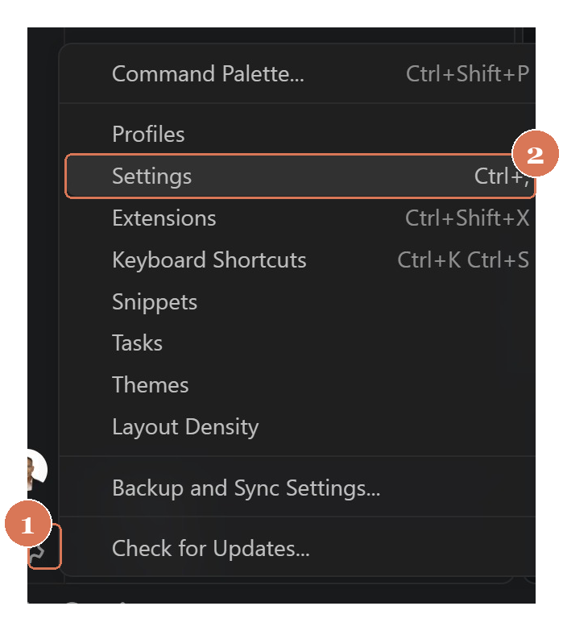
Figure 1 — VS Code: gear icon → Settings
- 1 Gear icon — bottom-left of VS Code.
- 2 Settings — or press Ctrl+, (Cmd+, on Mac); search “Claude Code” and tick “Allow dangerously skip permissions”, then pick Bypass permissions in the prompt-box mode menu.
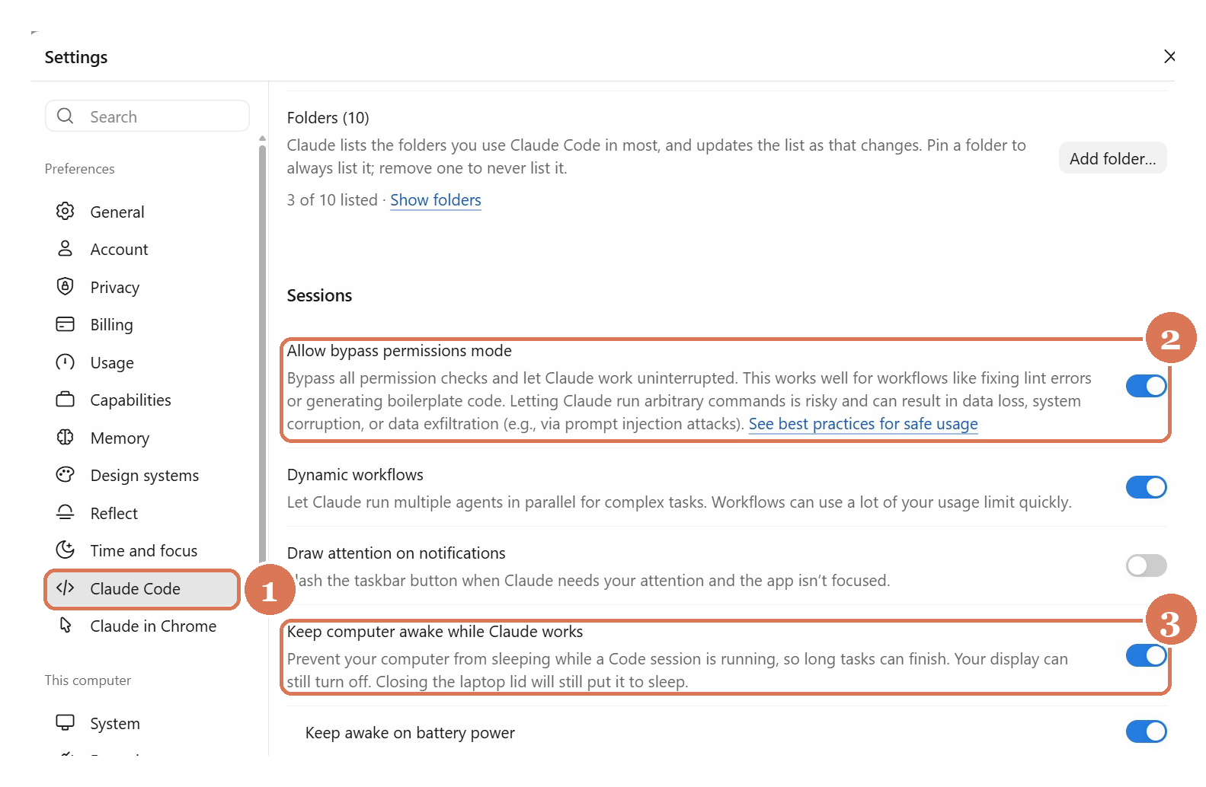
Figure 2 — Claude Desktop: Settings → Claude Code → Sessions
- 1 Settings → Claude Code — open the Claude Code page in Desktop settings.
- 2 Allow bypass permissions mode — toggle it on to make Bypass available in the mode menu.
- 3 Keep computer awake (optional) — stops the machine sleeping during long runs.

1.10 Managing Sessions
A session is a saved conversation tied to a project directory, stored locally as you work.
Command | What it does
claude --continue | Resume the most recent session in this directory
claude --resume | Open the session picker to browse/search
claude --resume <name> | Resume a named session directly
/rename <name> | Name the current session so it’s findable
/branch <name> | Fork the conversation to try a different approach
/clear · /compact · /context | Manage context within a session
Run parallel sessions on different branches with git worktrees (claude --worktree <name>).

1.11 Scheduled Tasks (Desktop Routines)
Scheduled tasks start a new Claude session automatically — great for daily code reviews, dependency audits, or morning briefings.
- In the Desktop app, click Routines → New routine → Local.
- Set a Name, Instructions (what Claude should do), working folder, and permission mode.
- Pick a Schedule: Manual, Hourly, Daily, Weekdays, or Weekly — or just describe it (“every 6 hours”).
- Run now once and approve any permission prompts so future runs don’t stall.
Local tasks run only while the app is open and your machine is awake. For runs that fire even when your computer is off, use cloud Routines.
Tip: you can create one by asking in plain language — “set up a daily code review that runs every morning at 9am.”

1.12 Keep Working Toward a Goal (/goal)
/goal sets a completion condition and Claude keeps working across turns until it’s met. After each turn, a small fast model (Haiku) checks the condition; the goal clears automatically once satisfied.
Command | What it does
/goal <condition> | Set a verifiable end state and start working toward it
/goal | Check status: turns, tokens, and the latest reason
/goal clear | Remove an active goal before it’s met
Write conditions Claude can prove in the transcript, e.g. all tests in test/auth pass and the lint step is clean. Bound long runs with a clause like or stop after 20 turns.

Activity 1 — Build & Deploy a Website
Goal: Build a single-page responsive website for a software development company, then push it to GitHub and deploy it on GitHub Pages.
This activity runs in two parts: Activity 1a covers Steps 1–3 (Goal & Features → Plan → Execute/build), then we cover context engineering in class, and Activity 1b covers Steps 4–7 (Context /init → Commit → Deploy → CI/CD) and presenting your live GitHub Pages link.

Step-by-step
- Create a project folder and open a terminal there:
- mkdir software-dev-site && cd software-dev-site
- Launch Claude Code (claude) or open the Claude Code panel in VS Code.
Get set up in VS Code. Before Step 1, install the extension and dock Claude Code beside your files.
Install the Claude Code extension in VS Code. Install only the official extension published by Anthropic — an extension can read your whole codebase.
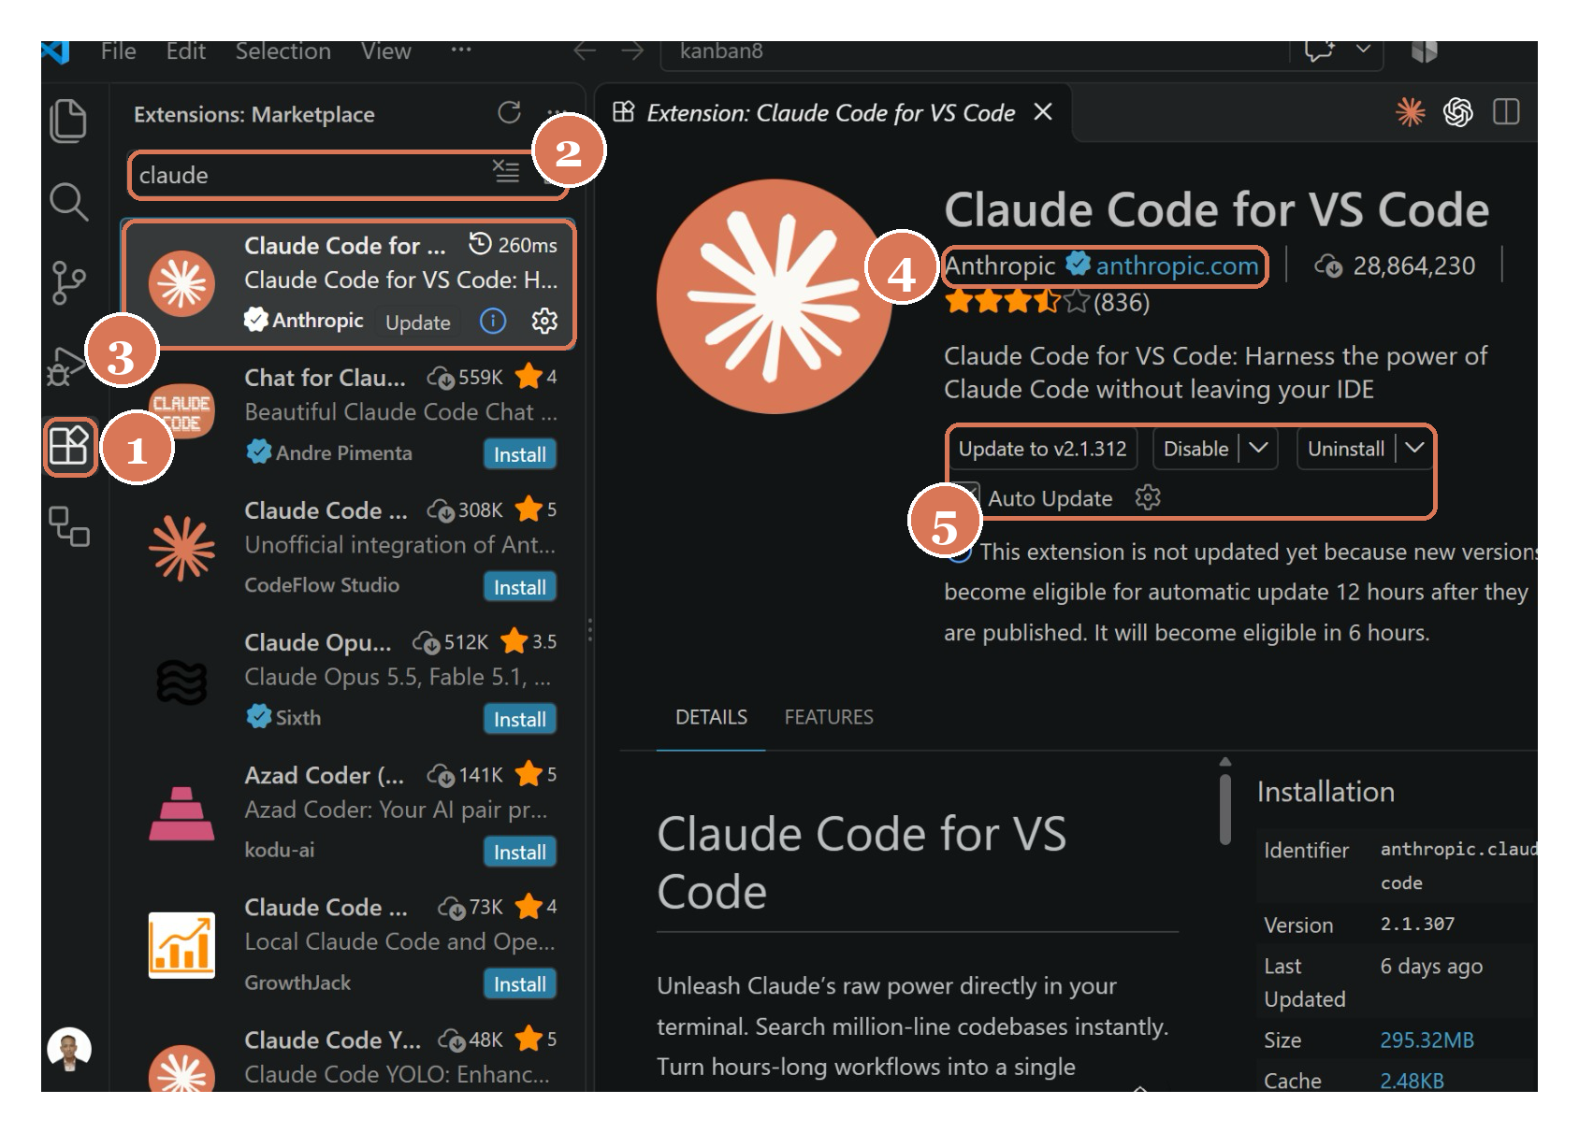
Figure 3 — Installing “Claude Code for VS Code” from the Marketplace
- 1 Open Extensions — click the Extensions icon or press Ctrl+Shift+X (Cmd+Shift+X on Mac).
- 2 Search “claude” — type claude in the Marketplace search box.
- 3 Pick “Claude Code for VS Code” — select the result published by Anthropic.
- 4 Check the publisher — look for the blue verified tick and anthropic.com; skip look-alike extensions.
- 5 Install & keep it updated — click Install and leave Auto Update ticked.
Move Claude Code to the secondary side bar. Right-click the Claude icon → Move To → Secondary Side Bar. Your files stay on the left, the editor in the middle and Claude Code on the right.
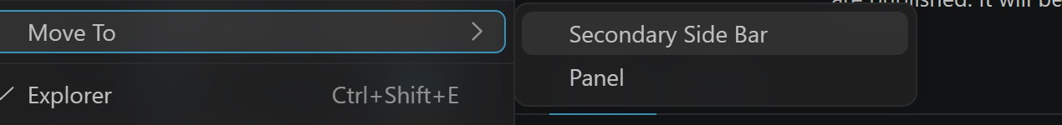
Figure 4 — Right-click the Claude icon → Move To → Secondary Side Bar
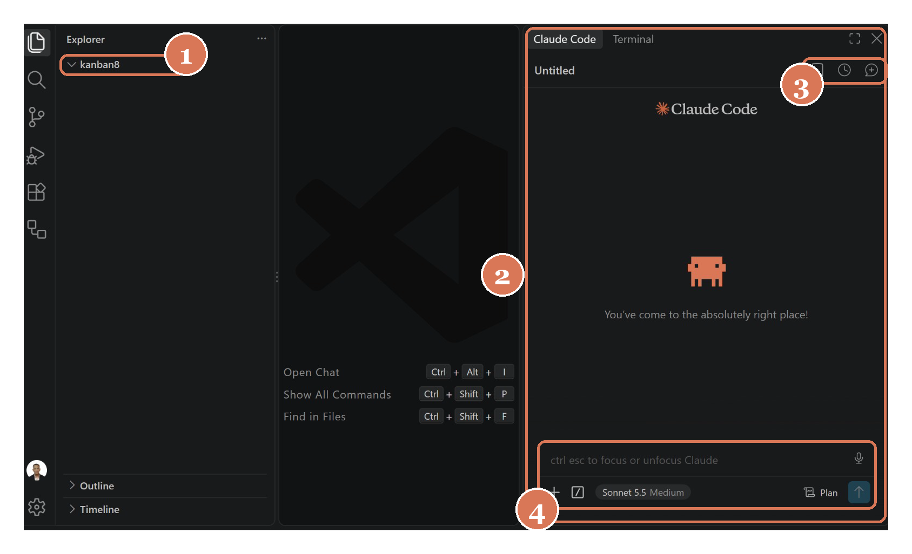
Figure 5 — VS Code with Claude Code docked in the secondary side bar
- 1 Files on the left — the Explorer shows your project folder (kanban8).
- 2 Claude Code on the right — chat with Claude while you watch files change in the editor.
- 3 New session & history — + starts a fresh session (Figure 6); the clock icon reopens past sessions.
- 4 Prompt box — Ctrl+Esc focuses Claude; / opens commands; choose Plan mode and the model here.
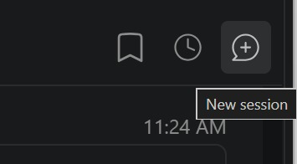
Figure 6 — The New session button
Or use the Claude Desktop app. Prefer a GUI? Open the Claude Desktop app, switch to the Code tab and point it at a project folder — it runs the same agentic loop as the CLI.
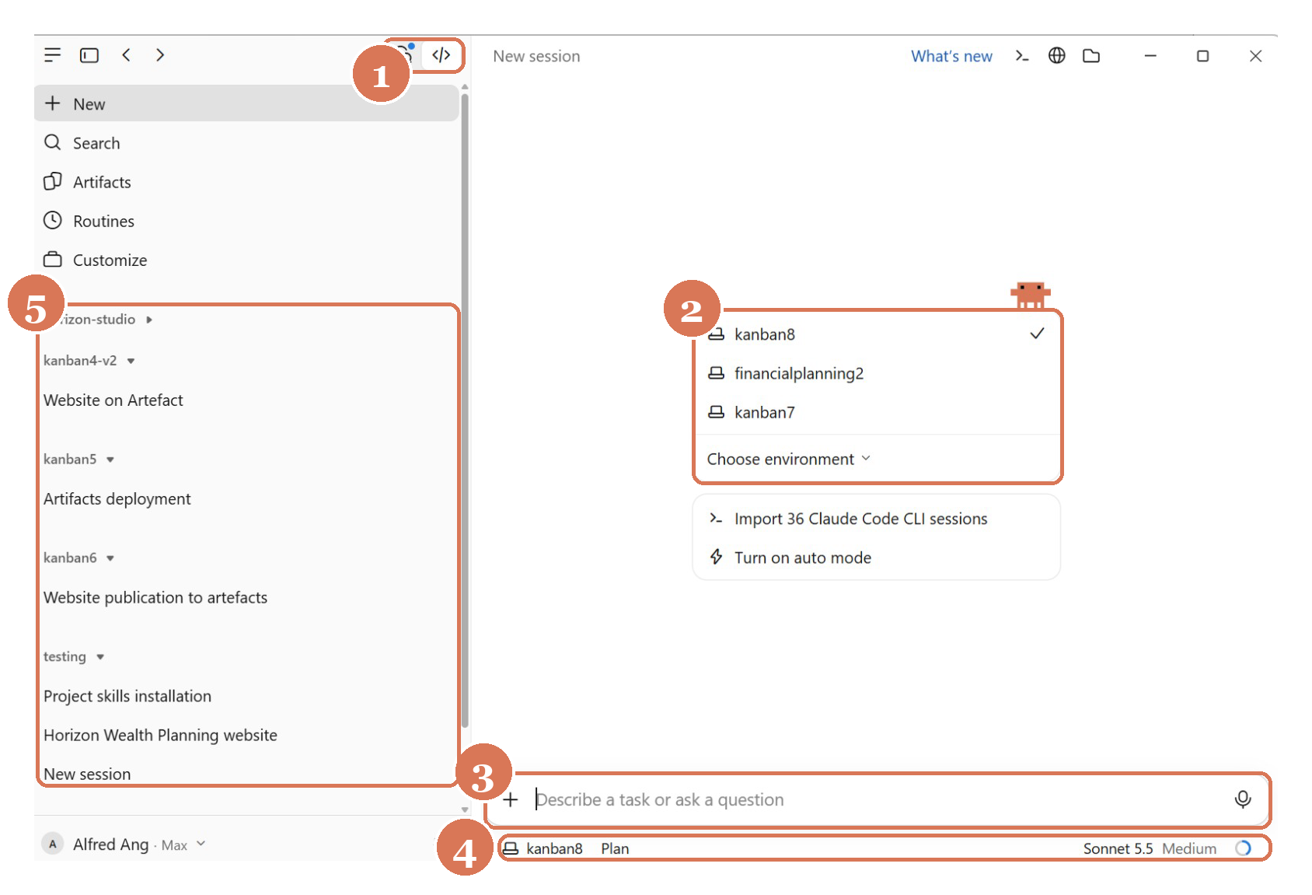
Figure 7 — Claude Code in the Claude Desktop app (Code tab)
- 1 Open the Code tab — click the </> icon at the top-left to switch from Chat to Claude Code.
- 2 Choose your project folder — pick a folder (here kanban8); Claude reads and edits files only inside it.
- 3 Describe the task — type your goal in plain English and press Enter.
- 4 Check folder, mode & model — the status bar shows the folder, permission mode (Plan) and model (Sonnet 5.5 · Medium).
- 5 Sessions grouped by project — the sidebar lists past sessions under each project; click one to resume. “Import Claude Code CLI sessions” brings your terminal history in.
Complete the 7-step build workflow:
- Step 1 — Goal & Features. Draft a detailed build prompt (use ChatGPT to expand your idea), then paste the website prompt below into Claude Code.
- Step 2 — Plan Mode. Press Shift+Tab to enter Plan mode and let Claude propose a plan; review it before approving.
- Step 3 — Execute (Bypass Permissions). Approve the plan and let Claude build the site hands-free. To enable bypass-permissions mode in VS Code: Settings → Extensions → Claude Code → enable “Allow dangerously skip permissions”, then pick Bypass permissions in the prompt-box mode selector (CLI: claude --dangerously-skip-permissions). Use this only in a trusted/sandboxed project. See Figures 1–2 in section 1.9.
- Step 4 — Context Engineering (/init). Run /init to generate a CLAUDE.md so Claude remembers the project’s structure and conventions. (See the example CLAUDE.md below.)
- Verify the build — open index.html in a browser; submit the enquiry form empty (errors show) and valid (confirmation + data logged to console).
- Step 5 — Commit to GitHub. Create an empty repository on github.com, then let Claude Code push your code.
- 1 Click New — on github.com go to Repositories and click the green New button.
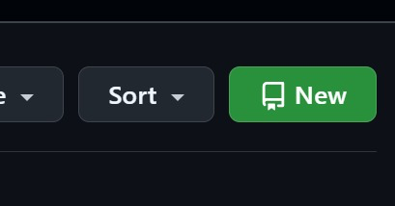
Figure 8 — The New repository button on GitHub
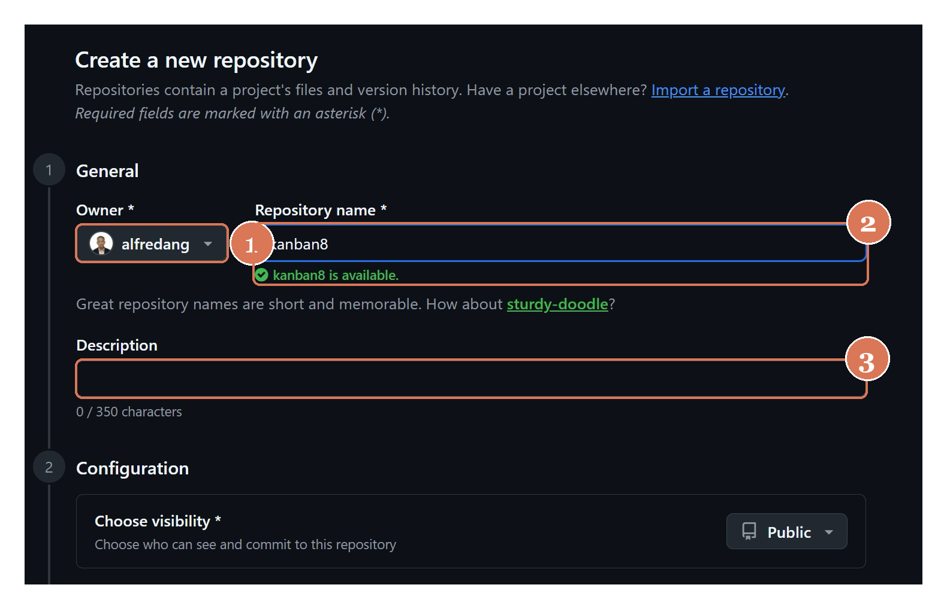
Figure 9 — Create a new repository — owner, name and description
- 1 Owner — keep your own GitHub account.
- 2 Repository name — e.g. software-dev-site (kanban8 in the screenshot); a green tick means the name is free. Use lowercase-with-hyphens — the name becomes part of your GitHub Pages URL.
- 3 Description (optional) — one line about the project.
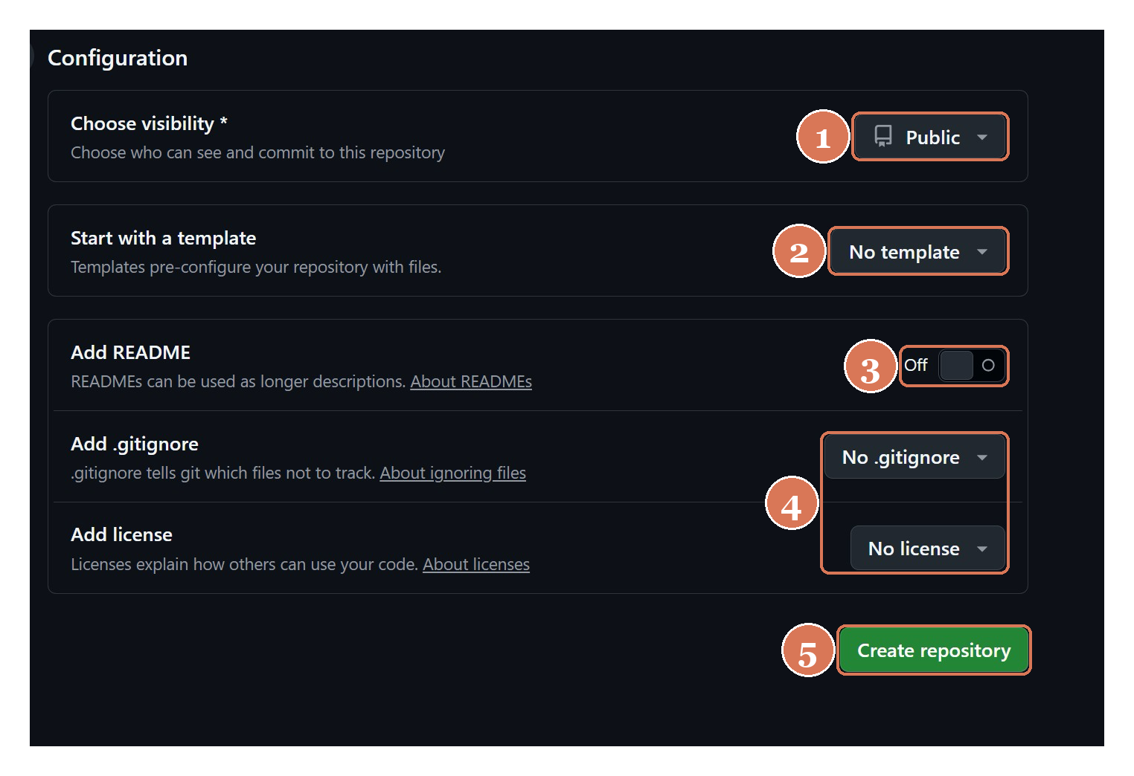
Figure 10 — Configuration — keep the repository empty
- 1 Visibility: Public — free GitHub Pages hosting needs a public repository.
- 2 No template — start from a blank repository.
- 3 README: Off — Claude writes the README in Step 6.
- 4 No .gitignore, no license — files created here would clash with your first push (the “rejected — fetch first” error).
- 5 Create repository — click the green button.
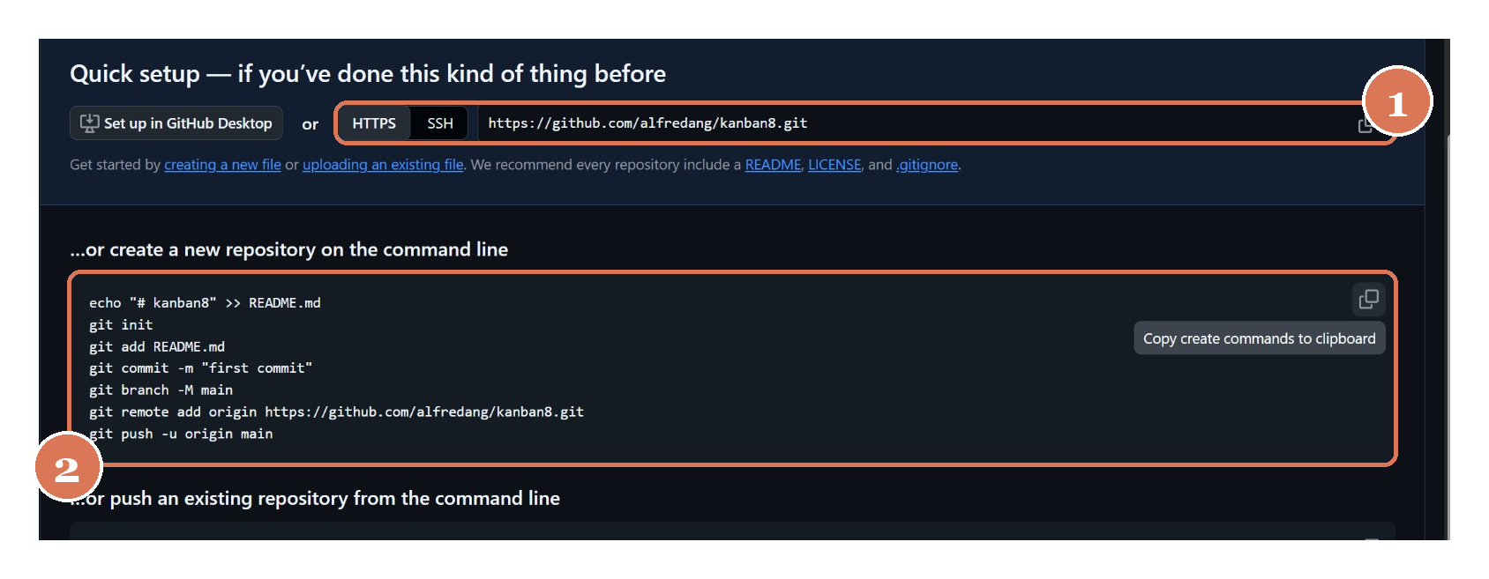
Figure 11 — Quick setup — the repository URL and git commands
- 1 Copy the HTTPS URL — click the copy icon beside https://github.com/<you>/<repo>.git.
- 2 The git commands — init → add → commit → branch -M main → remote add origin → push. You don’t need to type them — ask Claude:
- Commit all files and push this project to https://github.com/<username>/software-dev-site.git on the main branch.
Approve the GitHub sign-in when asked (or run gh auth login first), then refresh the repository page — your files appear, ready for Step 6. Prefer the GitHub CLI? This creates the repo and pushes in one go:
- git init && git add . && git commit -m "Initial website"
gh repo create software-dev-site --public --source=. --push
- Step 6 — Deployment (GitHub Pages via GitHub Actions) — ask Claude:
- Create a GitHub Actions workflow that deploys this site to GitHub Pages on every push to main, then enable Pages for the repo.
- Add a README, then visit https://<your-username>.github.io/software-dev-site/.
- Step 7 — CI/CD. Push a small change and confirm the GitHub Action automatically rebuilds and redeploys the site.

Example CLAUDE.md
# CLAUDE.md
## What this is
Single-page marketing site. HTML + CSS + vanilla JS — no framework, no build step.
## Running
Open index.html directly in a browser. No dev server.
## Architecture
- index.html — sections: #home, #services, #testimonials, #contact
- styles.css — design tokens in :root variables; mobile-first
- script.js — enquiry-form validation (one DOMContentLoaded handler)
Reference repo: https://github.com/alfredang/softwaredevleopment

The Website Prompt
Build a single-page, responsive website for a software development company using HTML, CSS, and vanilla JavaScript only (no frameworks). Output everything in one index.html file with inline <style> and <script>, or split into index.html, styles.css, and script.js — your choice.
Goal: A modern, professional landing page that markets custom software development services and captures leads through an enquiry form.
Sections (in order):
1. Hero Section — Full-width banner with a strong headline (e.g. “We Build Software That Scales”) and a one-line subheadline. Short supporting paragraph. Primary CTA button (“Get a Quote”) that smooth-scrolls to the enquiry form. Clean gradient or solid background, large readable typography, centered content. Optional navbar with logo and anchor links (Home, Services, Testimonials, Contact).
2. Testimonial Section — Section heading (e.g. “What Our Clients Say”). 3 testimonial cards, each with: client quote, client name, role/company, and avatar placeholder (initials circle or image). Responsive grid: 3 columns on desktop, 1 column on mobile. Subtle card shadows and hover effect.
3. Enquiry Form Section — Section heading (e.g. “Get in Touch”). Fields: Name (required), Email (required), Phone (optional), Service interested in (dropdown), Message (textarea, required). Submit button. Submission handled in JavaScript: intercept submit with event.preventDefault(); validate fields (required checks + email regex) and show inline error messages; on success show a confirmation message (“Thanks! We’ll be in touch shortly.”) and reset the form; log the collected form data as an object to the console. Include a commented-out fetch() example showing how to POST to an API endpoint.
Styling Requirements: Mobile-first and fully responsive (flexbox/grid + media queries). Consistent palette (CSS variables for primary, accent, background, text). Modern font stack or a Google Font. Smooth scrolling. Accessible: semantic HTML5, a label for every input, sufficient contrast.
Deliverable: Working, copy-paste-ready code that runs by opening the file in a browser — no build step.

Topic 2 — Tools and Commands

2.0 The .claude Directory
Claude Code keeps its configuration in two places — your user folder (applies to every project) and the project folder (shared with your team via version control).
User scope — ~/.claude/: settings.json (settings, hooks), CLAUDE.md (personal memory), agents/, skills/, commands/, projects/<project>/ (session transcripts + memory/), and plugins/. MCP servers and per-project local config live in ~/.claude.json.
Project scope — <project>/.claude/: settings.json (shared) and settings.local.json (personal, gitignored), CLAUDE.md and rules/, commands/ (slash commands), skills/<name>/SKILL.md, agents/<name>.md (sub agents). Project MCP servers live in .mcp.json at the repo root.
User scope applies everywhere; project scope is committed so your whole team shares the same commands, skills, agents and settings.
User level vs project level — where each customisation lives. Every customisation can be stored at two levels. User level (~/.claude/) applies to ALL your projects; project level (<project>/.claude/) applies only to that ONE project and travels with it in git (slide 43):
Commands — user: ~/.claude/commands/<name>.md; project: <project>/.claude/commands/<name>.md.
MCP tools — user: ~/.claude.json (claude mcp add -s user …); project: <project>/.mcp.json (claude mcp add -s project …).
Skills — user: ~/.claude/skills/<name>/SKILL.md; project: <project>/.claude/skills/<name>/SKILL.md.
CLAUDE.md — user: ~/.claude/CLAUDE.md (your personal memory); project: <project>/CLAUDE.md (shared with the team).
Hooks — user: the "hooks" block in ~/.claude/settings.json; project: the "hooks" block in <project>/.claude/settings.json.
Keep personal preferences at user level; commit team-shared rules, commands, skills and hooks at project level. Both levels load together — where they conflict, project settings take precedence.

2.1 Custom Commands
Custom commands are reusable prompts saved as Markdown files. Typing a slash command runs a multi-step workflow the same way every time.
- Location: .claude/commands/ in your project (or ~/.claude/commands/ for personal commands).
- Create one: make name.md — the filename becomes /name.
- Reload: restart Claude Code to pick up new commands.
- Arguments: use $ARGUMENTS to pass input into the command.

2.2 MCP Tools
The Model Context Protocol (MCP) is an open standard that lets Claude Code connect to external tools and data sources through a common interface.
- MCP Server — exposes tools/data (e.g. Playwright, GitHub, databases).
- MCP Client — Claude Code connects to servers and calls their tools.
- Transport — stdio or HTTP/SSE; transport-agnostic.
- Tools — each server publishes callable actions Claude can use.
Playwright MCP lets Claude drive a real browser — open pages, click, fill forms and capture screenshots.
Connecting a server. Register a server with claude mcp add, then verify with claude mcp list and manage in-session with /mcp. Servers are saved at one of three scopes:
Scope | Stored in | Available to
local (default) | ~/.claude.json (this project) | Only you, this project
project | .mcp.json in the repo root | Everyone who clones the repo
user | ~/.claude.json (top level) | Only you, all projects
# hosted (HTTP) server
claude mcp add --transport http docs https://code.claude.com/docs/mcp
# local (stdio) server, shared with the team via .mcp.json
claude mcp add playwright -s project -- npx -y @playwright/mcp@latest
claude mcp list

Activity 2 — Create a /gitpush Custom Command
Goal: Create a custom command that automates pushing, documenting, deploying and securing your project.

Step-by-step
- Create the commands folder in your project:
- mkdir -p .claude/commands
- Create the file .claude/commands/gitpush.md with the following content:
- ---
description: Push code to GitHub, create README, deploy Pages, secure the repo
---
Perform the following steps for this project:
1. Push/update all the code to GitHub (commit any changes first).
2. Create or update a README that documents the project.
3. Create a GitHub Page via GitHub Actions.
4. Update the repository "About" section and add the GitHub Pages link.
5. Run a security scan to make sure no sensitive data (API keys, secrets,
passwords, personal data) is published to the internet.
Target repository / notes: $ARGUMENTS
- Restart Claude Code so the new command is detected.
- Run the command:
- /gitpush software-dev-site
- Verify the repo has a README, GitHub Pages is live, the About section shows the Pages link, and the security scan reported no leaked secrets.

Activity 3 — Install & Use Playwright MCP
Goal: Install the Playwright MCP tool at the project level, screenshot your website and push it to GitHub.

Step-by-step
- Install Playwright MCP at the project level:
- claude mcp add playwright -s project npx @playwright/mcp@latest
- Restart Claude Code and approve the browser permissions when prompted.
- Confirm the server is connected:
- /mcp
- Ask Claude to screenshot your site:
- Use the Playwright MCP tool to open my deployed website (https://.github.io/software-dev-site/) and capture a full-page screenshot. Save it as screenshot.png.
- Add the screenshot to the README:
- Add screenshot.png to the README under a “Preview” heading, then commit and push to GitHub.
- Verify the screenshot renders correctly in your GitHub README.

Activity 3B — Test the Enquiry Form with Playwright
Goal: Use the Playwright MCP tool to test the enquiry form end-to-end and confirm submissions reach your email.

Step-by-step
- Wire the form to email. Ask Claude to send form submissions to angch@tertiaryinfotech.com — for example using a form service such as Formspree, or a fetch() POST to your endpoint:
- Connect the enquiry form so submissions are emailed to angch@tertiaryinfotech.com (use Formspree or a fetch to an endpoint).
- Open the site with Playwright:
- Use the Playwright MCP tool to open my deployed site (https://.github.io/software-dev-site/).
- Fill and submit the form with test data:
- Fill the enquiry form with name “Test User”, email “test@example.com”, a sample message, then submit it.
- Verify the on-page result — confirm the success message (“Thanks! We’ll be in touch shortly.”) appears and the form data is logged/captured.
- Check your inbox — confirm the enquiry email actually arrives at angch@tertiaryinfotech.com.
- Re-run the test after any change so every enquiry reliably reaches your email, then commit and push.

Topic 3 — Skills, Agents & Hooks

3.1 Agent Skills
Skills are reusable folders of instructions (SKILL.md) plus optional scripts and resources that teach Claude a specialised task. Claude loads a skill only when it is relevant.
- SKILL.md — name, description and instructions Claude follows on demand.
- Project skills — live in .claude/skills/, shared with your repo and team.
- Install — npx skills add <repo> --skill <name>.
- Customise — edit the skill to fit your project.
SKILL.md vs CLAUDE.md. Both are Markdown instruction files, and both tell Claude how you want work done. The difference is when Claude loads them — and that difference decides which one you should reach for.
SKILL.md — loaded on demand | CLAUDE.md — loaded every session
Trigger: Claude reads the skill's name + description and loads the body only when the task matches. | Trigger: read automatically at the start of every session — always in context.
Scope: one specialised capability — a workflow, an output format, a house standard. | Scope: project-wide facts — stack, conventions, commands to run, things not to do.
Cost: costs no context until it fires, so you can keep dozens installed. | Cost: spends context on every single turn, so keep it tight and high-value.
Lives in: .claude/skills/<name>/SKILL.md (or ~/.claude/skills/ for all projects). | Lives in: CLAUDE.md at the project root (or ~/.claude/CLAUDE.md for all projects).
Rule of thumb: put stable project facts in CLAUDE.md; put specialised, occasional procedures in a skill. If you find yourself writing "when I ask you to do X, follow these ten steps" in CLAUDE.md, that is a skill trying to escape.

3.2 Sub Agents
Sub agents are specialised assistants with their own prompt, tools and context window. Delegate focused jobs — like security review or UX critique — to keep the main thread clean.
- Create with /agents, then choose Project to save under .claude/agents/.
- Give a clear role — describe purpose, tools and when to invoke it.
- Isolated context — each sub agent runs in its own context window.
Why use sub agents? Reach for one when a side task would flood your main conversation with search results, logs or file contents you won’t reference again. Sub agents help you:
- Preserve context — exploration and logs stay in the sub agent’s own window; only the summary returns to your main conversation.
- Enforce constraints — limit exactly which tools the sub agent may use.
- Reuse & specialise — reuse configurations across projects (user-level agents) and give each a focused system prompt for its domain.
- Control costs — route narrow tasks to a faster, cheaper model.
Define a custom sub agent when you keep spawning the same kind of worker with the same instructions.

3.3 Hooks
Hooks are shell commands that run automatically at defined points in Claude Code’s lifecycle.
Event | When it runs
PreToolUse | Before a tool — validate or block an action.
PostToolUse | After a tool — auto-format or test.
Notification | When Claude needs input or finishes.
Stop | When a task ends — cleanup or checks.
Hooks are configured in .claude/settings.json under "hooks".
Automating with hooks. Hooks are deterministic — they always run at their event rather than relying on the model to choose to. Common uses: auto-format after edits, run tests, block risky commands, or send notifications. Add a "hooks" block with a matcher and a command; hooks receive event context on stdin as JSON. Example — format files after every edit:
{
"hooks": {
"PostToolUse": [{
"matcher": "Edit|Write",
"hooks": [{ "type": "command", "command": "npx prettier --write ." }]
}]
}
}

Activity 4 — Install & Run Skills
Goal: Install and run two skills to improve your website’s design and SEO.

Step-by-step
- Install the frontend-design skill at the project level:
- npx skills add https://github.com/anthropics/skills --skill frontend-design
- (This installs into .claude/skills/.)
- Customise the frontend design — ask Claude:
- Using the frontend-design skill, redesign my website to look modern and
professional and appeal to software-development clients. Improve the hero,
testimonials and form styling while keeping it responsive.
- Install the SEO audit skill:
- npx skills add https://github.com/coreyhaines31/marketingskills --skill seo-audit
- Run the SEO audit:
- Run the seo-audit skill on my website and apply the recommended changes
(title tags, meta description, headings, alt text, Open Graph, etc.).
- Commit and push the improvements to GitHub.

Activity 5 — Create Custom Sub Agents
Goal: Create two project sub agents — one for security, one for UI/UX & lead optimisation.

Step-by-step
- Create the security sub agent. Run:
- /agents
- Choose Create new agent → Project, then describe it:
- A security review agent that scans this website for vulnerabilities (XSS, exposed secrets, insecure form handling, missing headers) and recommends hardening measures.
- This saves to .claude/agents/.
- Run the security agent and apply its recommended fixes.
- Install the lead-magnets skill:
- npx skills add https://github.com/coreyhaines31/marketingskills --skill lead-magnets
- Create a UI/UX sub agent via /agents (Project) with this role:
- An expert UI/UX engineer that reviews the website and, using the lead-magnets skill, optimises it for lead capture and conversion.
- Run the UI/UX agent, apply improvements, then commit and push.

Activity 6 — Hooks (Floating WhatsApp Widget)
Goal: Add a floating WhatsApp widget to the website from Activity 1, and use a Claude Code hook so it auto-opens after 10 seconds with suggested queries and voice activation.
Claude Code hooks are shell commands that fire on Claude’s tool lifecycle (configured in .claude/settings.json, with scripts kept under .claude/hooks/). You don’t write them by hand — just ask Claude Code, in plain language, to create them. The widget behaviour itself lives in script.js on the site.

Step-by-step
Just ask Claude Code, in plain text, for each of these:
- Add the widget — ask Claude Code to add a floating WhatsApp widget fixed to the bottom-right of every page: a round WhatsApp button that expands into a small chat panel when clicked.
- Auto-open after 10 seconds — ask Claude to add a Claude Code hook (under .claude/hooks/, wired in .claude/settings.json) plus the page logic so the widget opens by itself 10 seconds after the page loads.
- Prompt and suggested queries — on auto-open, greet the visitor with “Hi! How can I help you?” and show 3–4 suggested queries as quick-reply chips (for example: course fees, schedule, funding). Add voice activation with the Web Speech API so the visitor can speak their question instead of typing.
- Test with Playwright — ask Claude to use the Playwright MCP tool to load the page, wait 10 seconds, and confirm the widget auto-opens with the greeting, the suggested queries and the voice-input control.

Activity 7 — Test, Optimise & Deploy
Goal: Test the enquiry form, add a WhatsApp widget, run final checks, deploy the final version and verify the live site.

Step-by-step
- Test the enquiry form with Playwright MCP:
- Use the Playwright MCP tool to fill in and submit the enquiry form with test data, and confirm the success message appears and the data is captured.
- Route enquiries to your email. Ask Claude to wire the form so submissions are sent to angch@tertiaryinfotech.com (e.g. via a form service such as Formspree, or a commented fetch() to your endpoint). Test that an enquiry arrives in the inbox.
- Add a WhatsApp floating widget — ask Claude:
- Add a WhatsApp floating widget fixed to the bottom-right of every page. On click it opens a chat to +65 9698 3731 with suggested starter queries (e.g. “I’d like a quote”, “Tell me about your services”).
- The link format is: https://wa.me/6596983731?text=<suggested message>.
- Run a final pass — re-run the security sub agent and the lead-magnet UI/UX sub agent, and apply any final improvements.
- Deploy the final version — run /gitpush to push, update the README and redeploy GitHub Pages.

Key Concepts Summary — What Triggers What
Claude Code can be extended in six ways. They differ mainly in what makes Claude load them: some are always present, some are pulled in only when relevant, some you fire yourself, and some are fired by an event or by another agent. Choosing the right mechanism is mostly a question of matching the trigger to the job.
Mechanism | Trigger — when it loads / runs
CLAUDE.md | Every session. Project memory, read automatically at the start of each session, so it is always in context. Generate with /init and keep it short and high-signal.
Skills (SKILL.md) | On demand. Claude matches the skill's name and description against the task and loads it only when relevant — so it costs no context until it fires.
Tools (built-in & MCP) | On demand. Claude invokes tools itself during the agentic loop whenever the job needs them — reading files, searching, running commands, driving a browser via MCP.
Slash commands | Manually. Reusable prompts saved in .claude/commands/; they run only when you type /<name> yourself. Use them for multi-step workflows you repeat.
Hooks | By event. Shell commands configured in .claude/settings.json that fire deterministically at lifecycle events (PreToolUse, PostToolUse, Notification, Stop) — they always run, rather than relying on the model to choose to.
Sub agents | By delegation. Specialised assistants with their own prompt, tools and context window, spawned when the main agent delegates a focused job and reports only the summary back.
Why it matters: anything loaded every session competes for the context window. Keep CLAUDE.md tight, and push specialised or occasional procedures out into skills, commands, hooks and sub agents — so Claude carries only what the current task actually needs.

Lab Materials
The hands-on labs are maintained in their own repository so you can clone them and keep working after class. Each lab folder contains a README that indexes its parts, and every step gives you the exact prompt to paste, what you should see, and a checkpoint to confirm before moving on.
Lab | What you build
Lab 1 — labs/lab1-seven-steps/ | Topic 1. The 7-step build workflow end to end: goal & features, plan mode, execute, /init context, commit to GitHub, GitHub Pages deployment and CI/CD. Includes a finished reference site and three sample sites (bridal booking, interior design, lead generator).
Lab 1b — labs/lab1b-commands-mcp/ | Topic 2. Build a /publish custom slash command that scans for secrets, pushes, deploys and updates the README; install Playwright MCP and use it to screenshot the live site into the README, then fold that step back into the command.
Lab 2 — labs/lab2-skills/ | Topic 3. Install the cybersecurity-analyst, agent-kanban and ui-ux-pro-max skills at project level, then use them to harden, plan and redesign the Lab 1 website in a green visual identity.
Lab 3 — labs/lab3-hooks/ | Topic 3. A Stop hook that pops a congratulations dialog, the floating WhatsApp widget with a guard hook, an add-task sub agent, a security-scan sub agent that writes security-scan.json, and /loop to re-scan on a schedule.
Labs repository: https://github.com/tertiarycourses/TGS-2025052468-Claude-Code

Quick Command Reference
Command | What it does
claude | Launch Claude Code
claude --continue / --resume | Resume the last / a chosen session
/init | Generate CLAUDE.md project memory
/memory | Browse & edit CLAUDE.md and auto memory
/context | See what’s using the context window
/compact | Summarise conversation to save context
/clear | Clear context for a new task
@file | Mention a file/folder to add to context
Shift+Tab | Cycle permission modes (default → acceptEdits → plan)
/rename · /branch | Name / fork the current session
/goal <condition> | Keep working until a condition is met
/mcp | View & manage connected MCP servers
/agents | Create / manage sub agents
/gitpush | Your custom push-deploy-secure command
claude mcp add <name> -s project <cmd> | Add an MCP server at project level
npx skills add <repo> --skill <name> | Install a skill

Support
If you have any enquiries during or after the class, contact us:
- Email: enquiry@tertiaryinfotech.com
- Tel: +65 6100 0613
Courseware & assessment: Download the courseware and complete the Written Assessment (WA) and Practical Performance (PP) on the LMS at https://lms-tms.tertiaryinfotech.com/.
Assessment flow (follow in order at the assessment step):
- Complete the TRAQOM survey — scan the TRAQOM QR code on the LMS.
- Take the Assessment Digital Attendance.
- Complete the Assessment (WA + PP).
- Submit your assessment answers on the LMS (https://lms-tms.tertiaryinfotech.com/).
- Sign the Assessment Summary Record.
Remember to complete your AM, PM and Assessment digital attendance, and the certification & TRAQOM survey at ai-lms-tms.tertiaryinfo.tech.

